# AI LAB EXPERIMENT N0: 8

**Algorithm:-**

**Step 1**: Start

**Step 2**: The user is expected to think of a animal and answer to the questions

shown in the prompt.

**Step 3**: The user answers the set of questions and the inference rule is drawn

from it.

**Step 4**: IF a conclusion to the premises result true it would display the name of

the animal otherwise the machine learns from the given set of input. **Step 5**: Repeat step 2 to 4 if the user want to make the guess again otherwise

go to step 6.

**Step 6**: Stop

**Identification of animal:** cheetah :- mammal, carnivore, verify(has_tawny_color), verify(has_dark_spots). tiger :- mammal,

carnivore, verify(has_tawny_color), verify(has_black_stripes). giraffe :- ungulate, verify(has_long_neck), verify(has_long_legs). zebra :- ungulate, verify(has_black_stripes). Classification rules:

mammal :- verify(has_hair), !. mammal :- verify(gives_milk). bird :- verify(has_feathers), !. bird :- verify(flys), verify(lays_eggs).

carnivore :- verify(eats_meat), !. carnivore :- verify(has_pointed_teeth),

verify(has_claws), verify(has_forward_eyes). ungulate :- mammal, verify(has_hooves), !. ungulate :- mammal, verify(chews_cud).

# CODE:-

import sys

def definiteNoun(s):

s = s.lower().strip()

if s in ['a', 'e', 'i', 'o', 'u', 'y']:

return "an " + s else:

return "a " + s

def removeArticle(s):

"Remove the definite article 'a' or 'an' from a noun." s = s.lower().strip()

if s[0:3] == "an ": return s[3:]

if s[0:2] == "a ": return s[2:] return s

def makeQuestion(question, yes, no):

return [question, yes, no] def isQuestion(p):

"Check if node is a question (with answers), or a plain answer." return type(p). name == "list"

def askQuestion(question):

print ("\r%s " % question,)

return sys.stdin.readline().strip().lower() def getAnswer(question):

if isQuestion(question):

return askQuestion(question[0]) else:

return askQuestion("Were you thinking about %s?" % definiteNoun(question))

def answeredYes(answer): if len(answer) > 0:

return answer.lower()[0] == "y" return False

def gameOver(message):

global tries print ("")

print ("\r%s" % message) print ("")

def playAgain():

return answeredYes(askQuestion("Do you want to play again?")) def correctGuess(message):

global tries gameOver(message) if playAgain():

print ("") tries = 0 return Q else:

sys.exit(0)

def nextQuestion(question, answer): global tries

tries += 1

if isQuestion(question):

if answer:

return question[1] else:

return question[2] else:

if answer:

return correctGuess("I knew it!") else:

return makeNewQuestion(question) def replaceAnswer(tree, find, replace): if not isQuestion(tree):

if tree == find:

return replace else:

return tree else:

return makeQuestion(tree[0], replaceAnswer(tree[1], find, replace), replaceAnswer(tree[2], find, replace)) def makeNewQuestion(wrongAnimal):

global Q, tries

correctAnimal = removeArticle(askQuestion("I give up. What did you think about?"))

newQuestion = askQuestion("Enter a question that would distinguish %s from %s:"

% (definiteNoun(correctAnimal), definiteNoun(wrongAnimal))).capitalize()

yesAnswer = answeredYes(askQuestion("If I asked you this question " + "and you thought about %s, what would the correct answer be?" % definiteNoun(correctAnimal)))

# Create new question node if yesAnswer:

q = makeQuestion(newQuestion, correctAnimal, wrongAnimal) else:

q = makeQuestion(newQuestion, wrongAnimal, correctAnimal) Q = replaceAnswer(Q, wrongAnimal, q)

tries = 0 return Q

def addNewQuestion(wrongAnimal, newques, correct): global Q

q = makeQuestion(newques, correct, wrongAnimal) Q = replaceAnswer(Q, wrongAnimal, q)

return Q tries = 0

Q = (makeQuestion('Does it have fur?', 'Tiger', 'Penguin'))

q = addNewQuestion('Tiger', 'Does it have dark spots?', 'Leopard')

q = addNewQuestion('Leopard', 'Is it the fastest animal?', 'Cheetah') q = addNewQuestion('Penguin', 'Can it fly?', 'Parrot')

q = Q

print ("Imagine an animal. I will try to guess which one.") print ("You are only allowed to answer YES or NO.") print ("")

try:

while True:

ans = answeredYes(getAnswer(q)) q = nextQuestion(q, ans)

except KeyboardInterrupt: sys.exit(0)

except Exception:

sys.exit(1)

# OUTPUT:-

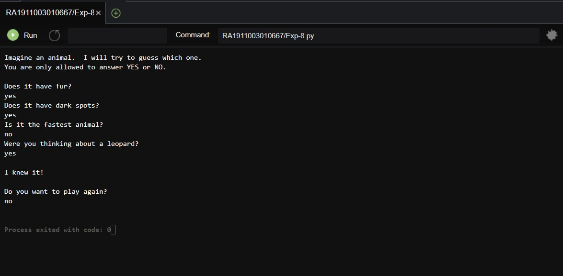

**RESULT:-**

Hence, the Implementation of rule based inference system is done successfully.